

Trackmatic integration guide

C:\Users\Yaseenh\Desktop\TrackmaticLogoAndForms\Trackmatic1jpg.jpg

Table of Contents

What we do 2

Types of services we offer 2

How to integrate with us? 3

**Step 1** 3

Types of connections 3

1. Web service request to Azure 3

2. Polling Listener 4

3. SFTP/FTP 4

4. Flat file Listener 5

**Step 2** 6

Basic questions and information from client 6

**Step 3** 7

Specific fields required for integration 7

Action 7

Deco 8

Routes 8

Entity 9

# ***What we do***

In short, trackmatic provides unique tailor-made software solutions to fleet operators and fleet management of On-Road Execution™ regardless of the fleet size.

We offer a holistic business solution to our clients, meeting their unique and complex requirements. We work together with them to provide insight into the finer workings of their operations, thereby increasing efficiencies and enabling greater levels of satisfaction among their customers.

Resource optimisation and service excellence are key outcomes of the solution, resulting in higher profits and driving down costs. This is where the true value of the solution is gained.

The table below summarises our solutions.

## Types of services we offer

|  |  |  |  |  |
| --- | --- | --- | --- | --- |
| On-Road ExecutionTM | Planning | Bureau | Insight | Mobility |
| Live Visibility | Backend Integration | On Road Execution Control Room | KPI Management | Turn by Turn Voice Guided Navigation |
| Historical Tracking | Route Builder | Full Audit | Planned vs Actual | Voice Calls |
| Advanced Delivery Notifications | Route Updates | DECO Management | Trending | Sign-on Glass Confirmation |
| Live Dashboards | Licensed Planning Algorithms | Voice Recordings | Driver Alignment |  |
| Risk Management | Third Party Planning Tools | Exception Based Alerts | Customised Automated Reporting |
| Speed Management | Data Integrity |  |  |

# ***How to integrate with us?***

To integrate and make use of trackmatics services, simply complete and follow the three steps below.

## **Step 1**

### Types of connections

It is vital for the client to pay special attention in the choice you make to connect to us. The client should base their choice primarily on ease of use and efficiency to improve business feasibility as well as maintain data integrity.

There are four main methods of connecting to trackmatic:

#### Web service request to Azure

The client presents the required data to our web service in XML or JSON. Upon receiving it, it is then mapped and uploaded into trackmatic.

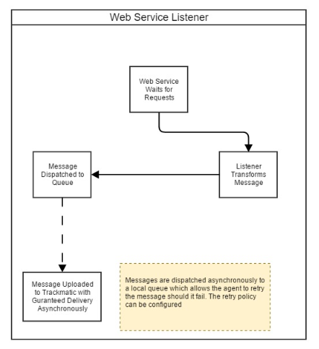

#### Polling Listener

This is installed as a service on the client’s local server or machine. It listens to a 'Trackmatic-Changes' table placed within the client’s database. This table records all the changes been made to the relevant client’s tables needed to use trackmatics services. These changes in relation to the tables are then traced, picked up and updated in trackmatic.

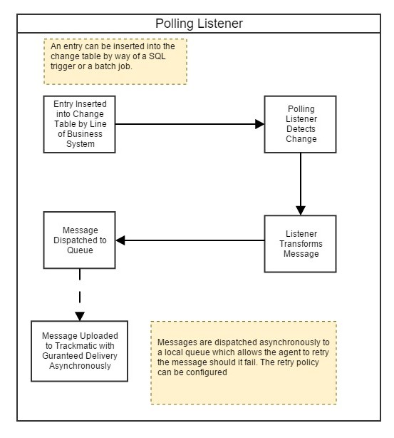

#### SFTP/FTP

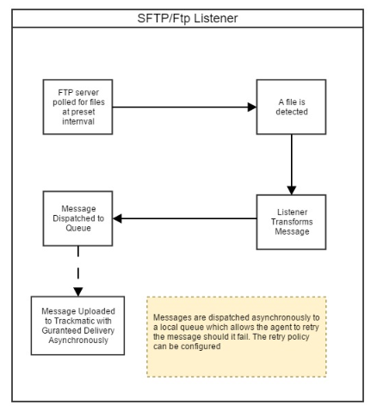The client drops an excel extract (CSV) to the sftp/ftp server containing all the relevant data to use trackmatics services. The integration agent polls the directory of the sftp/ftp for the file. If an extract is picked up, it is then read in and uploaded into trackmatic. The client can choose to use their own sftp/ftp server (preferable) or trackmatics sftp/ftp server.

#### Flat file Listener

Very similar to sftp/ftp. The client drops an excel extract (CSV) containing all the relevant data to use trackmatics services onto a local directory in trackmatics server. The integration agent which is running on trackmatics server will poll the directory for the file. If an extract is picked up, it is then read in and uploaded into trackmatic If an extract is picked up, it is then read in and uploaded into trackmatic.

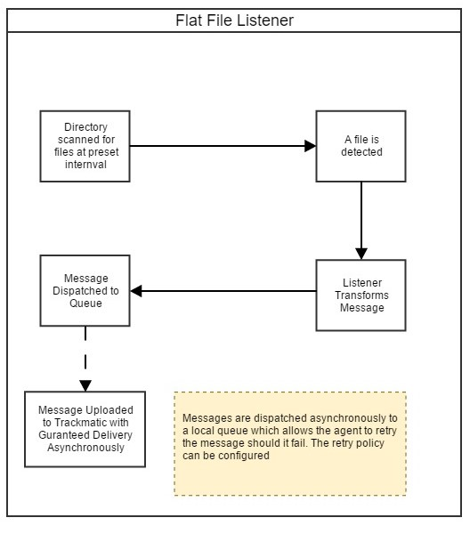

## **Step 2**

### Basic questions and information from client

Below are some questions and basic information that a client will be inquired about and expected to provide to trackmatic. This should be taken into account when considering an integration with trackmatic.

Questions

* Are the Ship -To addresses adhoc or static?
* Are the Start and End locations for the delivery vehicles the same?
* Do you facilitate next day deliveries?
* Do you facilitate for cash on deliveries?
* Do you provide any of the following services: Inter-branch transfers, uplifts, customer to collect?
* How many sites do you service (Isando, Kempton park, East Rand etc.)?

Information

* Contact details of the technical and business people involved in facilitating the integration.
* Sample data from the client’s business. Documentation like as invoices, waybills, delivery notes, trip sheets (all paper work the driver requires) etc. This should be provided in excel (csv) format as well as the physical copies of the documentation.
* If trackmatic needs to integrate with external systems, then trackmatic will need to be provided with the details for the systems. For example, IP addresses, port numbers, logon credentials and firewall rules.

## **Step 3**

### Specific fields required for integration

The fields below per section, if provided, can be created within trackmatic.

An example for each section has been provided for clarity.

Please note that not all fields are mandatory unless specified in the second column.

|  |  |  |  |
| --- | --- | --- | --- |
| **Action(What)** | | | |
| A basic example of an action in trackmatic is an ***invoice*** or ***delivery***. | | | |
|  | Field Name | Mandatory | Description |
| 1 | Id | Yes | Unique system generated id prefixed with the provided client id |
| 2 | Reference | Yes | Unique reference number associated with the action |
| 3 | Volumetric Mass | No | The volume of the parcel |
| 4 | Weight | No | Weight of the parcel |
| 5 | Pieces | No | Number of pieces in the action |
| 6 | Unit | No | Unit of measure |
| 7 | Instructions | No | Special instructions |
| 8 | Customer Reference | No | Client supplied reference number |
| 9 | Customer Code | No | Unique client code |
| 10 | Expected Delivery | No | Date the action is expected to be executed |
| 11 | Pallets | No | Number of pallets associated with the action |
| 12 | Amount Incl | No | Monetary value of the action including vat |
| 13 | Amount Excl | No | Monetary value of the action excluding vat |
| 14 | Reference_Internal | No | Internal reference number for workflow i.e. picking slip, sales doc etc. |
| 15 | IsCod | Yes | Cash On Delivery Indicator |

#### Action

#### Deco

|  |  |  |  |
| --- | --- | --- | --- |
| **Deco (Where)/ Ship-To** | | | |
| A basic example of a Deco in trackmatic is the **area/location** of the entities (Mall Of Africa has entities like Edgars, Woolworths etc.). | | | |
|  | Field Name | Mandatory | Description |
| 1 | Id | Yes | A unique reference number (Ship-to identifier) |
| 2 | Name | Yes | Common name of the DECO |
| Address | | | |
| 3 | Unit No. | No | Unit No. |
| 4 | Building Name | No | Building Name |
| 5 | Street No. | No | Street Number |
| 6 | Sub Division No. | No | Sub Division Number |
| 7 | Street | No | Street Number |
| 8 | Suburb | No | Street |
| 9 | City | No | City |
| 10 | Province | No | Province |
| 11 | Postal Code | No | Postal Code |
| 12 | Map Code | No | Map Code |
|  | Contacts | No | If YES, either First Name or Surname is required |
| 13 | First Name | Yes | First name of the contact |
| 14 | Last Name | No | last name of the contact |
| 15 | Tel No | No | Telephone number of the contact |
| 16 | Cell No | No | Cell phone number of the contact |
| 17 | Email | No | Email address of the contact |

#### Routes

NB: An entity, deco and action should be specified for each route.

|  |  |  |  |
| --- | --- | --- | --- |
| **Route (Travel path)** | | | |
| A basic example of a Route in trackmatic is the **specified travel path** in which a delivery is to be made. | | | |
|  | Field Name | Mandatory | Description |
| 1 | Id | Yes | Unique system generated id prefixed with the provided client id |
| 2 | Reference | Yes | A unique reference number for the route |
| 3 | Planned Start | Yes | Planned start date and time |
| 4 | Registration | No | Registration number of the vehicle being assigned to the route |
| 5 | Name | No | A name or number of the route |
| Crew | | | |
| 6 | Id | Yes | Unique system generated id prefixed with the provided client id |
| 7 | Reference | Yes | Personnel Unique Identifier issued by Client |
| 8 | Name | Yes | Personnel Name |
| 9 | Type | Yes | Personnel Type (Driver or Crew) |
| 10 | Identity No. | No | Identity number of crew member |
| 12 | Cell No. | No | Cell phone number of crew member |

#### Entity

|  |  |  |  |
| --- | --- | --- | --- |
| **Entity (Who) /Sell-To** | | | |
| A basic example of an Entity in trackmatic is the **individual stores/customers** within an area and their details (Edgars in Mall Of Africa). | | | |
|  | Field Name | Mandatory | Description |
| 1 | Id | Yes | A unique reference number associated with the Entity |
| 2 | Name | Yes | The name of the entity |
| 3 | Reference | Yes | A unique reference number for the entity (Sell-to identifier) |
| Contact | | | |
| 5 | First Name | No | First name of the contact |
| 6 | Last Name | No | last name of the contact |
| 7 | Tel No | No | Telephone number of the contact |
| 8 | Cell No | No | Cell phone number of the contact |
| 9 | Email | No | Email address of the contact |
| Address | | | |
| 12 | Address Field 1 | No | Address Field 1 |
| 13 | Address Field 2 | No | Address Field 2 |
| 14 | Address Field 3 | No | Address Field 3 |
| 15 | Address Field 4 | No | Address Field 4 |
| 16 | Address Field 5 | No | Address Field 5 |
| 17 | Postal Code | No | Postal Code |
| Requirements | | | |
| 18 | Action Debrief | No | Success or Failure of the action that was to be executed. Per entity, it can be stated if you would like an entity debrief. |
| 19 | Cod Debrief | No | Review of Cod deliveries 1) EFT POP 2) Cash 3) No Cash 4) Accounting Pin. Per entity, it can be stated if you would like a Cod debrief. |
| 20 | Signature | No | Sign On Glass required after an action is debriefed. Per entity, it can be stated if you would like the signature feature. |

